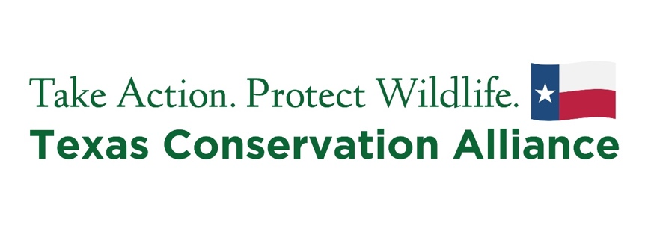

**Organization**: Texas Conservation Alliance, state affiliate of the National Wildlife Federation

**Position:** Lights Out College Station Intern

**Job Type:** 12-week Internship

**Target hire date:** August 23, 2024

**Start date:** September 9, 2024

**End date:** November 30, 2024

**Schedule:** 15 hours per week, including occasional weekends   
**Work Location:** Projects are conducted in College Station and are paired with required online check-ins (Mondays, 12 pm – 1 pm), reporting, and intern cohort collaboration.

**Stipend:** TCA is pleased to provide an internship stipend of $1200/semester ($200 distributed bi-weekly)

**About Texas Conservation Alliance**

For over 50 years Texas Conservation Alliance (TCA) has advocated for wildlife and their habitats since 1971. TCA educates Texans and builds alliances to enhance and sustain wildlife habitat and to protect our land, air, and water for future generations. TCA has built public support to establish numerous wildlife refuges, state and federal parks, wilderness areas, and other wildlife areas, resulting in more than 250,000 Texas acres protected. TCA has recruited thousands of Texans to active conservation and advocacy through grassroots coalitions and community-driven, hands-on habitat restoration programs that welcome all communities into conservation and promote stewardship for Texas’ wildlife and wild places.

**General Summary**

Texas Conservation Alliance (TCA) is seeking interns who are passionate about protecting Texas wildlife and their habitats, to lead bird collision surveys on the Texas A&M College Station campus for the Lights Out program and engage the campus community to support the expansion of the LOCS program.

Lights Out is a behavior-change campaign aimed at saving migratory birds by encouraging businesses and residents to turn off non-essential lights during spring and fall migration. Bird collision surveys are an important component of scientific research. TCA leads surveys on the Texas A&M campus in College Station, during spring (March-May) and fall (September-November) migrating seasons. Interns will help lead the survey two days a week.

Selected candidates will receive comprehensive training at the start of the position and work with TCA staff to lead bird collision surveys. The 12-week internship offers opportunities to positively impact wildlife and provides valuable, hands-on learning experiences and professional development opportunities applicable to future careers in sustainability and conservation.

**Responsibilities**

**Lights Out bird collision surveys:**

* Conduct bird collision surveys at least twice a week (Monday, Wednesday, and Friday; 6-8 am).
* Lead groups of community volunteer surveyors.
* Rescue and release stunned and injured birds upon recovery.
* Collect extraneous collision specimens as found/reported.
* Manage storage of collected specimens.
* Assist with recording data in online databases

**Community Outreach:**

* Represent TCA and engage the campus community by assisting with education and tabling outreach events to inform the public about the dangers that light pollution poses to migratory wildlife.
* Promote Lights Out campaign with local entities, including governments, local conservation organizations, local press and media outlets, and community members to increase awareness and encourage others to take action to protect birds.

**Physical Abilities and Work Environment:**

* Early morning availability from 6 am – 9 am.
* Ability to walk outdoors for 2-3 hours.
* Occasionally required to lift and move items up to 25 pounds.

**Requirements:**

* Enrolled student at Texas A&M University (any major)
* Availability and internet access for weekly update meetings, every Monday from 12 pm – 1 pm (meetings extend to 1:30 pm during professional development sessions)
* Must have a reliable form of transportation
* At least 18 years old
* Eligible to work in the United States

**Preferred Qualifications:**

* Previous research/lab experience
* Familiarity with bird identification

**To Apply**

*Candidates must complete steps 1 and 2 to be considered.*

1. Please download and fill out the application on the internship page of the TCA website: <https://www.tcatexas.org/internships>
2. Email your application, resume, and cover letter to [**Jose@tcatexas.org**](mailto:Jose@tcatexas.org).

Please reach out to Skyler Nix, LOCS Program Coordinator ([**skyler.nix@ag.tamu.edu**](mailto:skyler.nix@ag.tamu.edu)) if you have any questions.

**Deadline to submit: Friday, August 16, 2024, at 5 pm**

*Texas Conservation Alliance is firmly committed to inclusion, diversity, and equity as core tenets of the organization, where everyone is respected and valued regardless of race, creed, ancestry, marital status,*

*veteran status, gender identity, sexual orientation, age, disability, religion, or national origin. Individuals from underrepresented backgrounds who do not meet all qualifications are encouraged to apply.*

