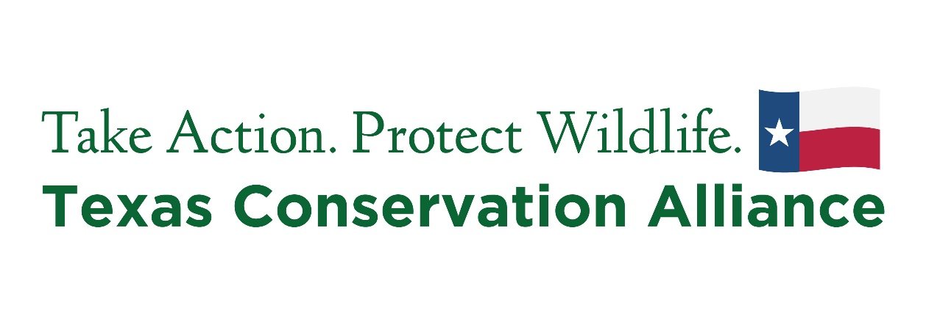

**Careers in Conservation Internship Program**

**For which semester are you applying? (No Lights Out internship during Summer)**

SPRING SUMMER FALL

**Name:**

**Address:**

**City, State, Zip:**

**Email:**

**Phone number:**

**Are you currently enrolled in school?**  Yes No   
 If yes, please answer the following questions:  
 1. School Name:  
 2. Major:  
 3. Year in school:  
 4. Anticipated or actual graduation date:

**(Optional) Please provide one professional reference indicating: 1) Full Name; 2) Relation; 3) Contact email and phone number**

**What are your future career plans?**

**Please select the TCA project that you are applying for. (Review the Internship description. Submit separate applications for each position. All Lights Out positions available Spring and Fall only)**

Native Plant Restoration

East Texas Conservation Internship

Lights Out Dallas (LOD)

Lights Out Fort Worth (LOFW)

Lights Out College Station (LOCS)

**What are your expectations of an internship with TCA? Please list three things you hope to achieve.**



Please email your resume and a cover letter with this completed application to **Jose@tcatexas.org**.